Vocabulary: ________________________

Instructions: For each word, indicate with an X where you fall for each on the table.

Vocabulary | I am unsure of the definition | I have heard of the word  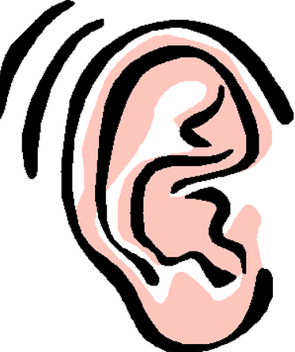 | I think the definition is…. | Other words I know with the same definition | Definition
10.

